Explore the world with Lions International


The Lions International Youth Camp & Exchange Program 2025 with Ringwood & Fordingbridge Lions Club



Who are we?

Ringwood & Fordingbridge Lions Club is a registered charity and part of an international network of approximately 45,000 Lions Clubs operating around the world collectively as Lions International. Lions internationally are dedicated to working with young people in the community, corresponding to International, National and Local requests for assistance in times of need.

What is it all about?

Ringwood & Fordingbridge Lions Club have helped many local students to visit International Lions Camps in America, Canada, Australia, China, Hong Kong, Hawaii, Finland, Sweden, Japan, Denmark, Italy, Spain, Mexico, Taiwan, Malaysia, Germany, Belgium and France amongst others. The scheme enables you to attend a residential youth camp (usually 1-2 weeks) in a country of your choosing, and also to experience life in that country by staying with a host family for 1-3 weeks. It happens generally in the summer holidays, and there are usually over 100 camps to choose from around the world.

What is the purpose of the scheme?

Multiple places are available on this scheme which is designed to promote friendship, travel and a greater international cultural awareness for those aged between 16 and 22. The scheme offers you the opportunity to:-

- visit extraordinary places and explore other countries and their cultures
- create lifelong memories and friendships with other young people your own age from around the world
- see what it is like to live with a family in the country you choose to visit
- meet people your own age from countries around the world
- become an International Ambassador for the UK, your town and our Lions Club

How can I apply?

Download an application form from www.randflions.org.uk. All completed applications must be returned by Friday 1 November 2024.

What happens next?

Ringwood & Fordingbridge Lions will review your application. All short-listed applicants will be invited to attend a short informal interview with their parent(s)/guardian(s). Everyone will find out the outcome of his/her application before the end of November 2024 and then shown how to apply for a place at the camp of their choosing.

You will need a valid passport (with at least six months before expiry on your expected date of travel) and any necessary travel visas, vaccinations and documents required for entry (please check the foreign office travel and the local embassy websites for further details).

What will happen at the Youth Camps?

- You will make lots of new friends your own age from different parts of the world.
- exploring historical landmarks, areas of outstanding natural beauty, places of interest - cultural, commercial and tourist.
- Possibly attending functions and meeting civic dignitaries
- Finding out about the culture of the region you are visiting and having fun
- Participating as a group in camp activities, sightseeing, shopping and organised trips

Will I need to know a foreign language?

English is spoken at most camps so there is no need to worry. It would be useful for you to know a little of the local language particularly when you stay with the host family. However, when you choose an international camp it will be made clear to you in advance if you need a good knowledge of the local language.

How much does it cost?

You will be expected to fund your own travel arrangements to and from the country of choice, have in place adequate travel insurance and sufficient spending money. You will also need a valid passport and any international visas for your travel. All of your accommodation costs, food etc… is usually provided by the Lions Organisation in the country you are visiting. Additionally, most international youth camps have no fee but some do which often cover the cost of any activities you will be involved in.
Any camp fees are clearly identifiable in advance and if there is a fee you will be expected to meet the cost of this. However, if you would like to apply but think that cost could be a problem, please come and talk to us about this as we might be able to help.

What if I have any questions?

Further information is available from our website (www.randflions.org.uk) and the at yex@randflions.org.uk, or alternatively call us on 0345 8335819 and we will do our best to help.

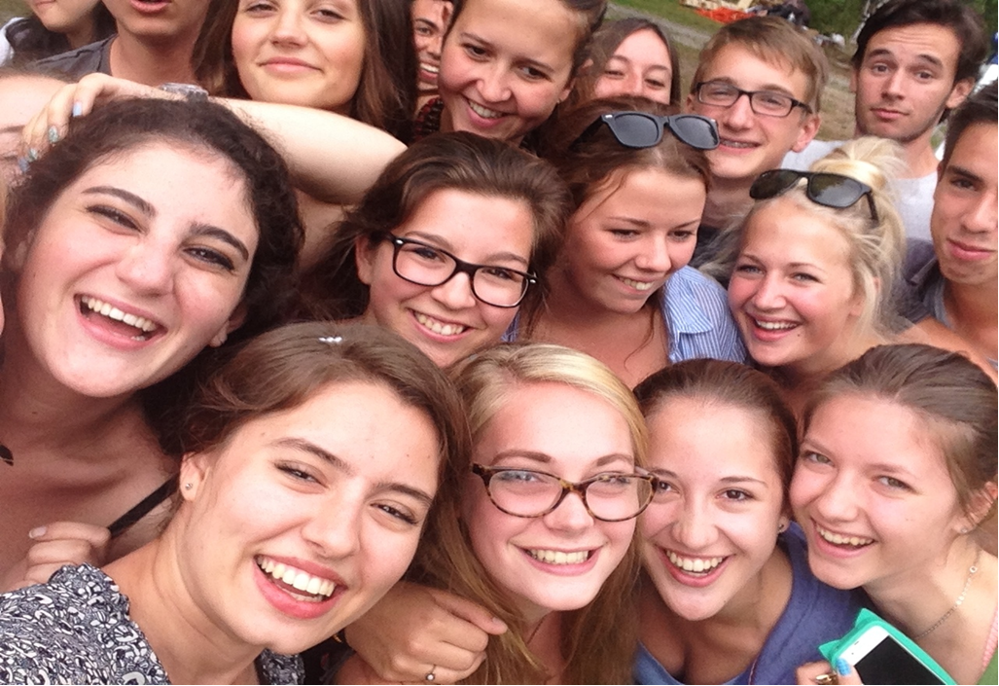

Fun, Friendship & Adventure

